Final Project Documentation

Project Prerequisites

Languages used for our project

* Html
* Css
* BootStrap
* Django
* Ajax
* Json

Project features

* For Admin
* Add books
* Remove books
* Update books
* View all books
* Update stock status and availability
* Issue books

For students

* View books
* Select books
* Add student profile
* Edit profile

Project File Structure

Models.py

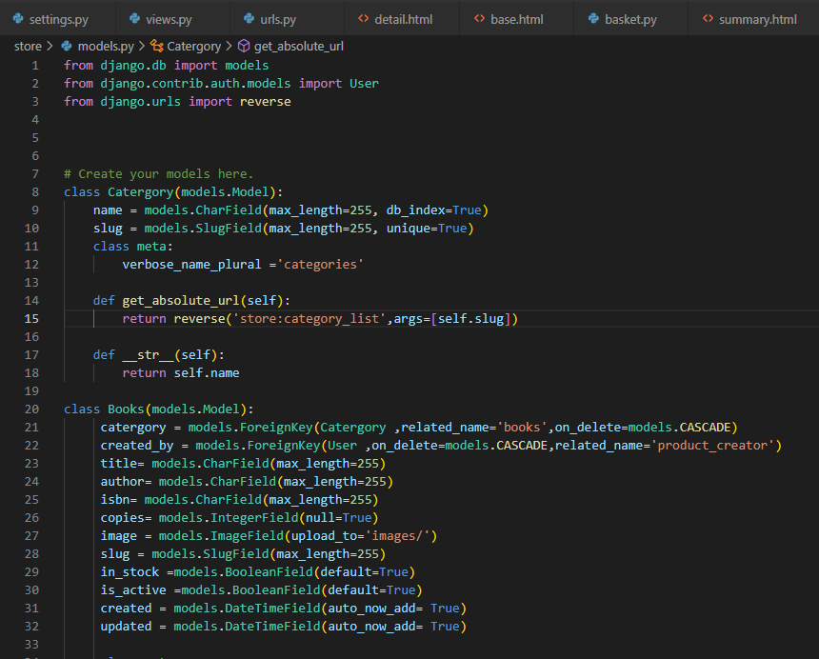

**Code Explanation:**

Category model:

where we shall store our genre this links to our books in the database

Book model:

Adds and stores our books to our Database

Student Model:

Adds students to the Database, updates profiles, and selects books

Transaction Model:

Tracks the books issued to students, it issues, returns, and removes the books from the transaction list.

URLs.py

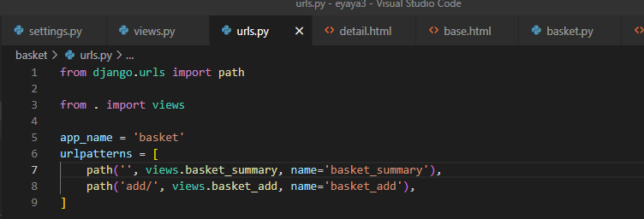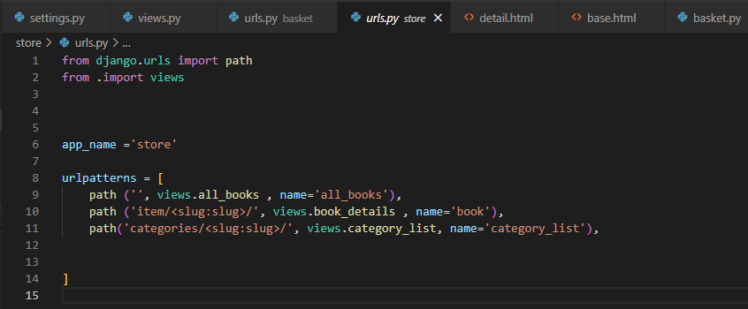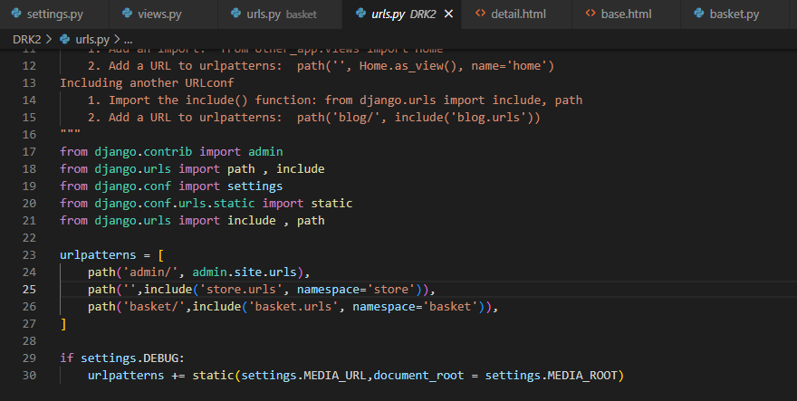

**Code Explanation:**

Basket URL

It allows users to select books and add them to the cart.

The basket will also display the list of books chosen by the student.

Store URL

Fetches books from the database using the category/genre as the linkage (slug) to the books

Main file URL

Links to admin login and database

Views.py

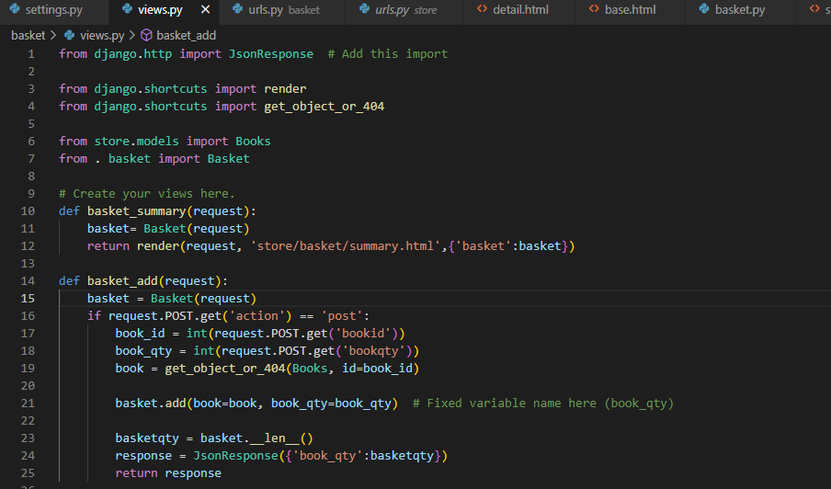

View.basket_add

Adds books and book quantities selected and added to the cart

Posts the quantity in our html page

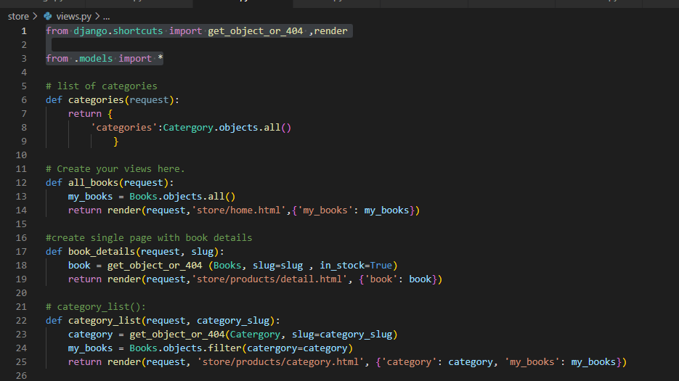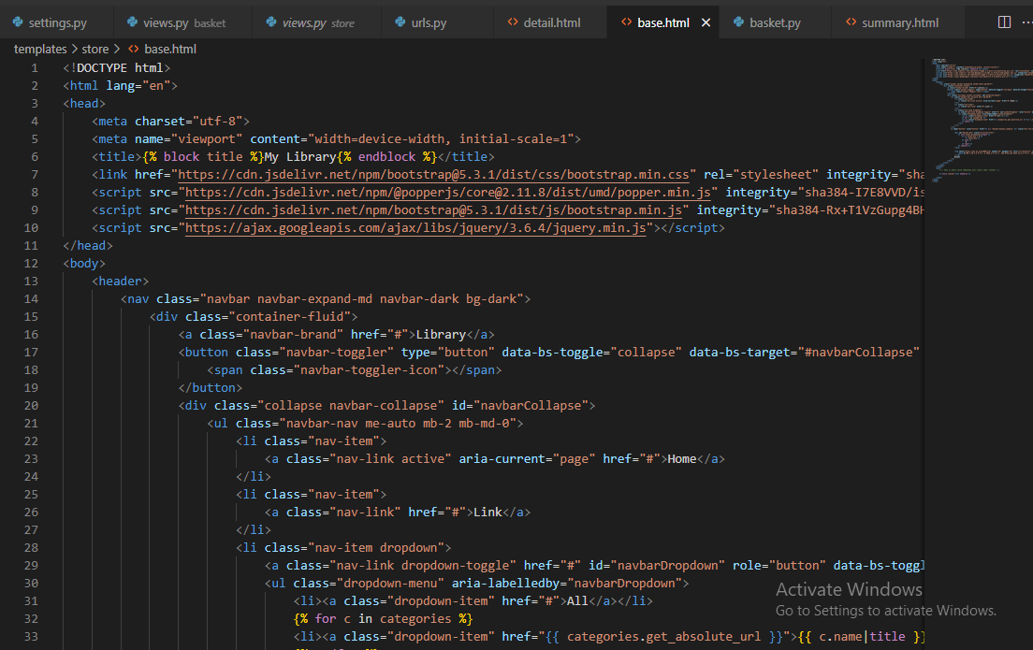

View.store.py

Displays books on our home page.

Shows all books we have in stock, and books not in stock will not display once clicked on.

The category list displays books that belong to that category.

THE HTML CODE

Base.html

Helps us avoid duplicating our codes and creates a single template for all other pages have to connect to.

Also allows our coding to be more organized.

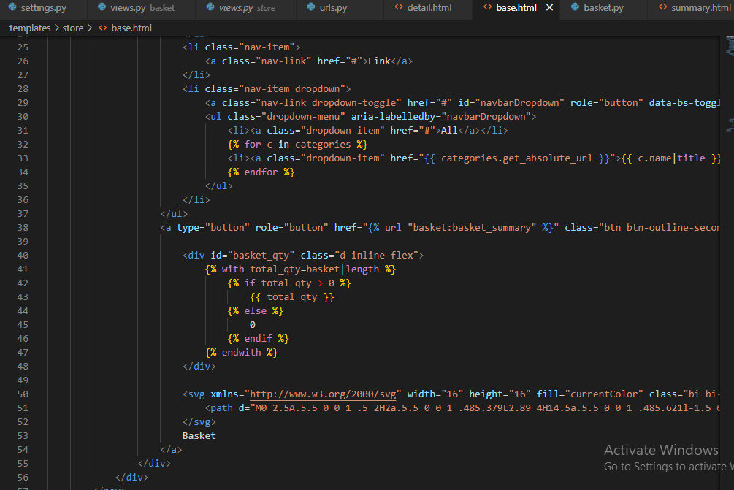

Summary HTML

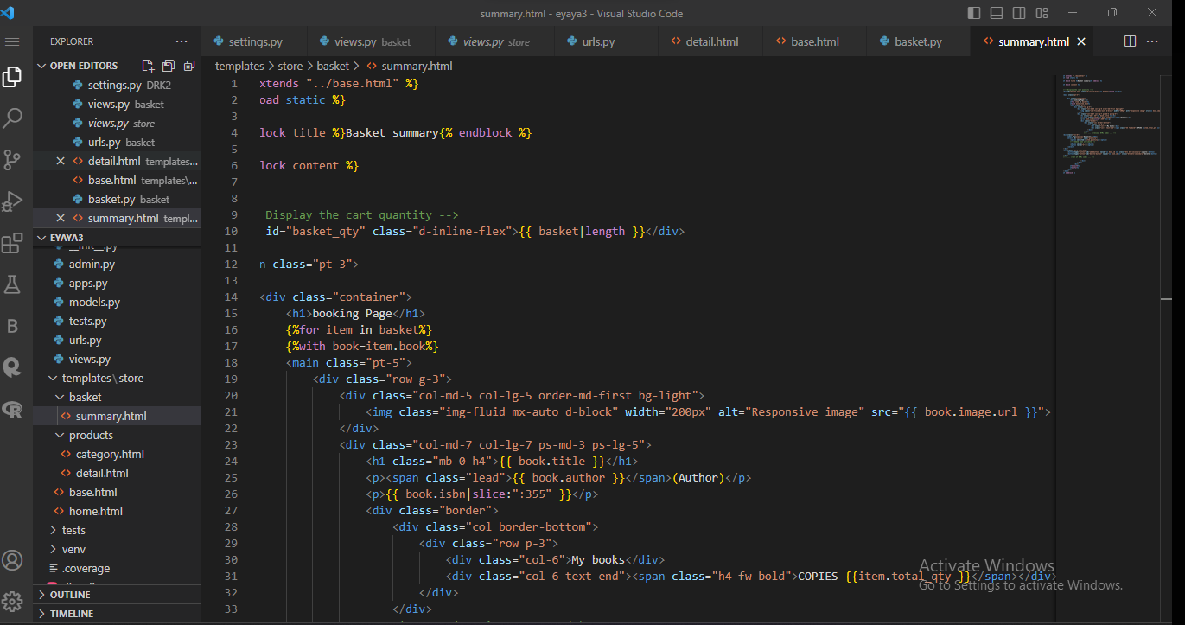

Here books we selected will appear as a list.

Single book details here are details.html shows the image, book author, title, number of copies

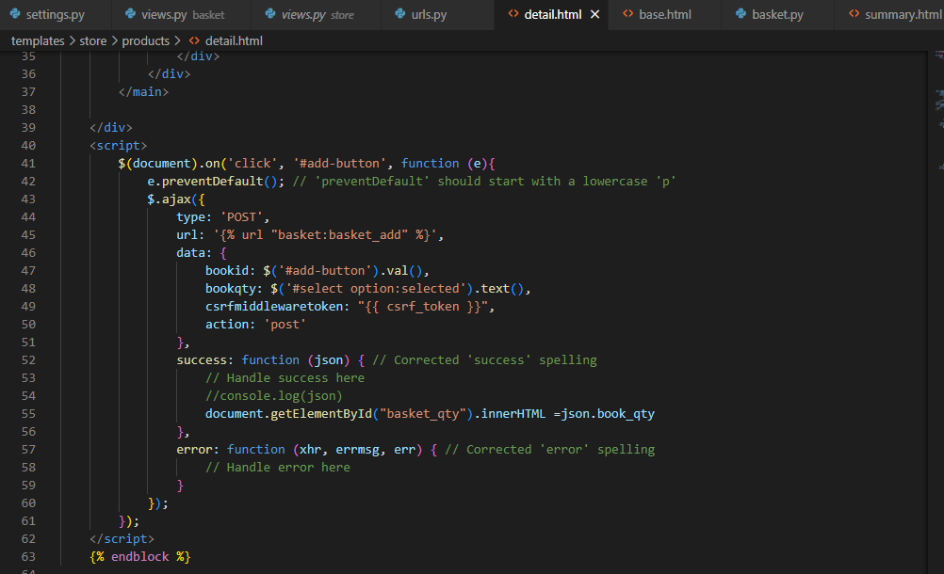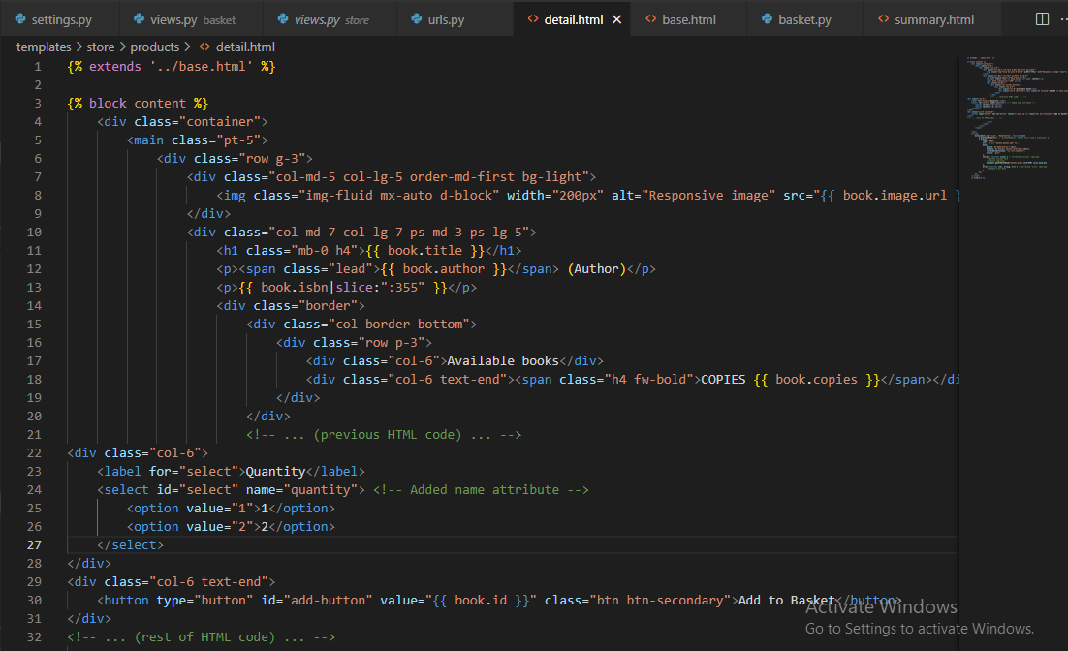

From our main menu, once you click a book, it takes you to that individual book and shows you all details about it.

In summary, with Django, we have been able to develop our Project to add books to our database, display them on our home page, select book of interest add to the list.